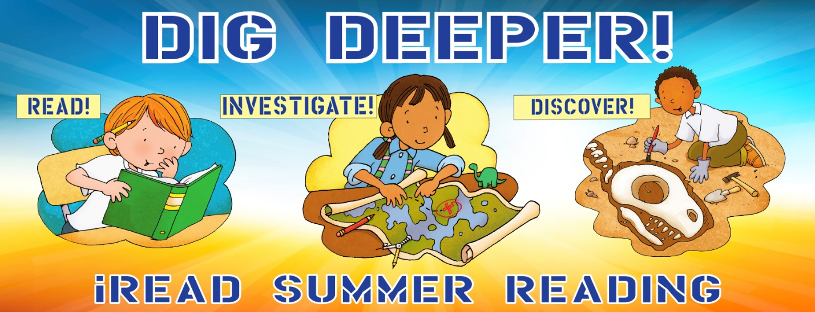
Beginning Readers Reading Chart
Register  Online | Read  15  Minutes | Read  15  Minutes | Investigate Flight  Make a loop plane | Read  15  Minutes | Read  15  Minutes | Discover  Ada Twist  at the  Library
Read  15  Minutes | Post a pic of your pet/  Stuffed animal | Read  15  Minutes | Read  15  Minutes | Discover Creativity  Chalk Art  @ library  July 13-17. | Read  15  Minutes | Read  15  Minutes
Investigate the skittle experiment from the kit | Read  15  Minutes | Read  15  Minutes | Discover Art  Play the  Roll & Draw  Game | Read  15  Minutes | Discover Fun!  Make a  Popper Cup | Read  15  Minutes
Read  15  Minutes | Investigate  Insects  Make a  Bug Catcher | Read  15  Minutes | Read  15  Minutes | Discover an Obstacle Course at the library  July 6-11 | Read  15  Minutes | Investigate Motion  Make a  2 wheel car
Investigate Insects  Make a paper dragonfly | Read  15  Minutes | Investigate Space  Make a pocket  Solar system | Read  15  Minutes | Read  15  Minutes | Post a picture of yourself reading | Read  15  Minutes
Read  15  Minutes | Read  15  Minutes | Read  15  Minutes | Discover Humor  Answer riddles on Facebook | Read a  Book featuring  an Insect | Read  15  Minutes | Read  15  Minutes
Read  15  Minutes | Watermelon  Burst at the  Library  July 31 @10 | Read  15  Minutes | Read  15  Minutes | Read  15  Minutes | Turn in  your  Reading Chart | Yeah!  You read  450  minutes

