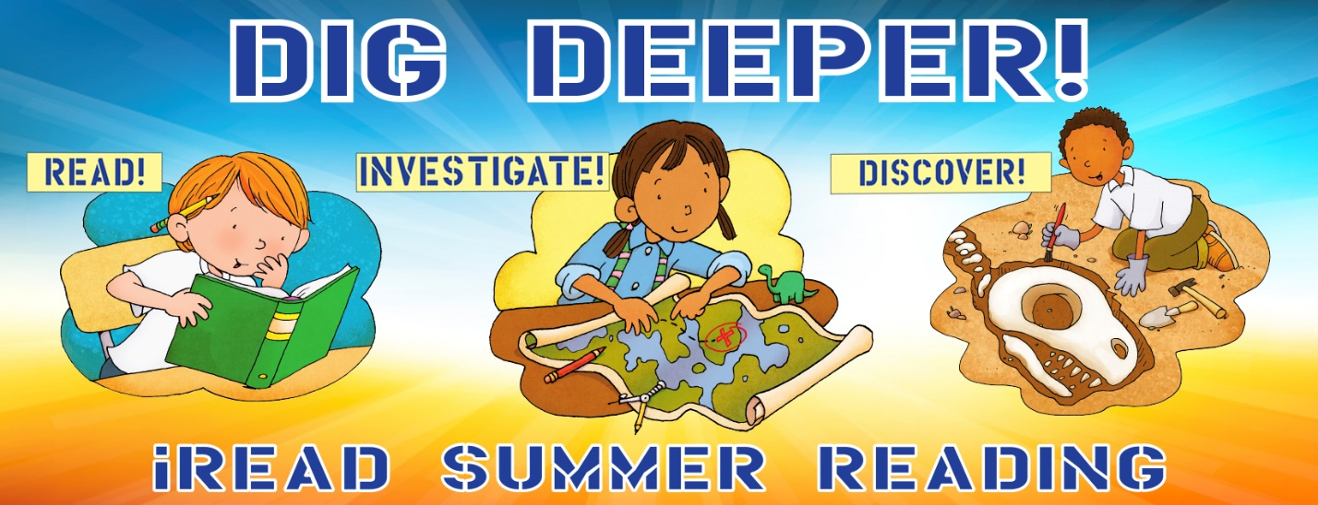Chapter Book Reader Chart
Register  Online | Read  25  pages | Investigate  Fight  Make a  Loop plane | Read  25  pages | Read  25  pages | Discover Art  Play the  Roll & Draw  Game
Read  25  pages | Discover Fun  Make a  Popper Cup | Read  25  pages | Discover Creativity  Chalk Art  @ the library  July 13-17 | Discover Humor  Answer Riddles  on our facebook page | Read  25  pages
Read  25  pages | Read  25  pages | Investigate  The skittles  Experiment  From the kit | Read  25  pages | Discover  Ada Twist  At the  Library | Read  25  pages
Post a  Picture of  Yourself  Reading | Read  25  pages | Investigate  Insects  Make a  Bug catcher | Read  25  pages | Read  25  pages | Investigate  Motion  Make a  2 wheel car
Read  25  pages | Investigate Space  Make a  Pocket  Solar system | Read  25  pages | Discover an  Obstacle course  @ the library  July 6-11 | Read  25  pages | Read  25  pages
Read  25  pages | Watermelon  burst  at the library  July 31 @10 | Read  25  pages | Read  25  pages | Turn in  Your  Reading Chart | Yeah!  Your read  500  Pages

