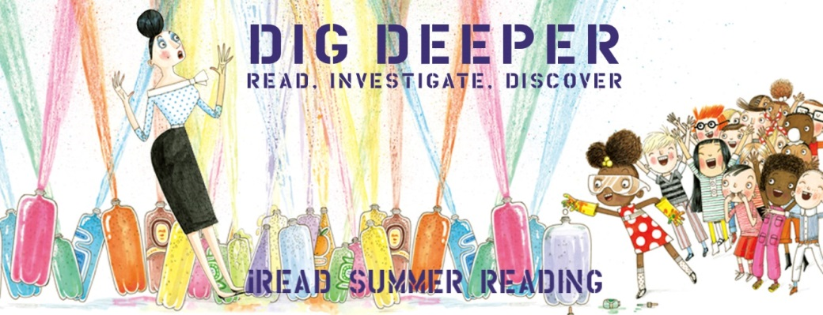
We read  1  book | We read  2  books | Register  Online | We read  3  books | Discover  Ada Twist at the library | We read  4  books | We read  5  books | Investigate Flight make a loop plane from the craft kit.
We read  7  books | Discover creativity Chalk Art @ library.  July 13-17 | We read  6  books | We read  8  books | We read  9  books | Post a picture of yourself reading a book | We read  10  books | We read  11  books
We read  13  books | We read  14  books | We read  12  books | Investigate the skittle experiment from the  craft kit | We read  15  books | We read  16  books | We read  17  books | Post a picture of your pet/stuffed animal
We read  19  books | Discover Art  Play the roll &Draw  Dice game | We read  18  books | We read  20  books | We read  21  books | We read  22  books | Discover  An Obstacle course at the library  July 6 - 11 | We read  23  books
We read  25  books | We read  26  books | We read  24  books | Discover Fun!  Make a Popper Cup! | We read  27  books | We read  28  books | We read  29  books | We read  30  books
Investigate Space  Make a pocket Solar System | We read  32  books | We read  31  books | We read  33  books | We read  34  books | Investigate Motion  Make a  2 wheel car! | We read  36  books | We read  37  books
We read  39  books | We read  40  books | We read  38  books | Investigate Insects!  Make a paper dragonfly | We read  41  books | We read  42  books | We read  43  books | We read  44  books
Watermelon burst at the library!  July 31 @ 10. | We read  46  books | We read  45  books | We read  47  books | We read  48  books | We read  49  books | Turn in  Your Reading Chart | Yeah!  50  books
READ TO ME CHART

